39.38: (a) Single slit diffraction: 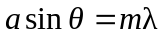
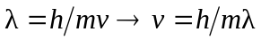
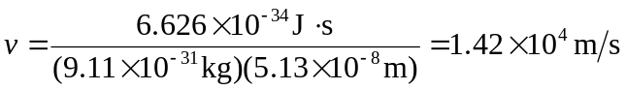
(b) 